**Heading:**

Document Name: Sprint 3 Plan

Product Name: SlugPath

Team: Slugstras

Sprint Completion Date: March 7, 2018

Revision 1.0 (2-23-18)

**Goal:**

Collect data to populate map with accurate paths. Finish developing shortest path algorithm.

**Task Listing:**

* User Story 1: As students, we need to prepare our presentation of our project so that we can get a good final grade.

User Story 1 Tasks

1. Create presentation
2. Create presentation script
3. Make sure each team member speaks the same amount as the others

* User Story 2: As a data manager, I want to figure out how to represent our data so that our developers can effectively use the data

User Story 2 Tasks

1. Create map nodes for each big node location

* User Story 3: As a UX Designer, I need to beautify the website so that users will be attracted to the site and so that the layout is not confusing.

User Story 3 Tasks

1. Find a framework (optional)
2. Pick consistent color scheme and fonts
3. Organize key application elements into its own space

**Team Roles:**

Joven Pableo: Product Owner and Developer

Edward John Tagaca: Developer

Cameron Skaggs: Week 1 Scrum Master, Data Management and Developer

Pranav Salunk: Developer

Srijitha Somangili: Week 2 Scrum Master and Developer

**Initial Task Assignment:**

Joven Pableo: User Story 1: Create presentation, Create presentation script, Make sure each team member speaks the same amount as the others. User Story 2: Create map nodes for each big node location.

Edward John Tagaca: User Story 1: Create presentation, Create presentation script, Make sure each team member speaks the same amount as the others. User Story 2: Create map nodes for each big node location. User Story 3: Pick consistent color scheme and fonts, Organize key application elements into its own space.

Cameron Skaggs: User Story 1: Create presentation, Create presentation script, Make sure each team member speaks the same amount as the others. User Story 2: Create map nodes for each big node location.

Pranav Salunk: User Story 1: Create presentation, Create presentation script, Make sure each team member speaks the same amount as the others. User Story 2: Create map nodes for each big node location.

Srijitha Somangili: User Story 1: Create presentation, Create presentation script, Make sure each team member speaks the same amount as the others. User Story 2: Create map nodes for each big node location. User Story 3: Pick consistent color scheme and fonts, Organize key application elements into its own space.

**Initial Burnup Chart:**

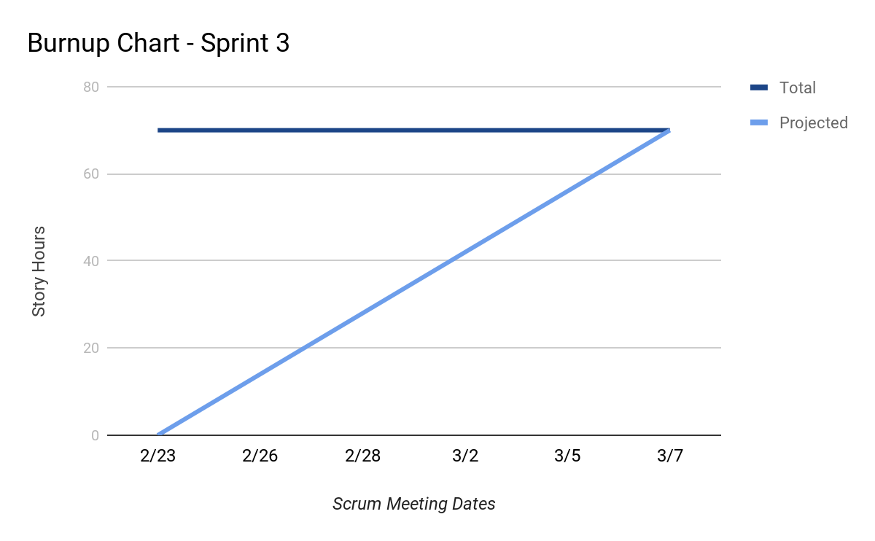

**Initial Scrum Board:**

**To Be Inserted**

**Scrum Times:**

Monday: 12:00 PM - 12:15 PM

Wednesday: 12:00 PM - 12:15 PM (Scheduled TA visit)

Friday: 12:00 PM - 12:15 PM